**Taguig City University**

Gen. Santos Avenue, Central Bicutan, Taguig City

**college of business management**

**bachelor of science in office administration**

**COURSE MODULE IN ofa 2 – ADMINISTRATIVE oFFICE PROCEDURES AND MANAGEMENT**

**I. Title: The Basics of Administrative Office Management**

**II. Introduction**

Administrative management has been defined as that function within the organization with responsibility for overall operations of the enterprise. Thus, it reflects the vastly altered and enlarged scope of management responsibilities in a modern enterprise.

**III. Overview**

Study of basic office management is having a clear idea of what office is and how it improved. Various activities in office developed from simple to complex. Those were the years when the responsibilities of office managers are simple and easy to perform.

**IV. Objectives**

After studying this lesson, you are expected to be able to:

1. Appreciate the administrative office management concept,
2. Define the role of management in the workplace.

**V. Lesson 1. The Administrative Office Management Concept**

Management is the process of working with and through other to blend together people, materials, money, methods, machines and morale in an effort to set and to achieve goals of the organization.

Advocates of Administrative Management - by Henry Fayol

1. Division of work
2. Authority and responsibility
3. Discipline
4. Unity of Command
5. Unity of Direction
6. Subordination of individual interest to general interest.
7. Remuneration of Personnel
8. Scalar Chain
9. Order
10. Centralization
11. Equity
12. Stability of Tenure
13. Initiative
14. Esprit de corps

Advocate of Bureaucratic Management – Max Weber was the major contributor to bureaucratic management. Based on observation, Weber concluded that many early organizations were inefficiently manage with decisions based on personal relationships and loyalty.

Advocates of Behavioral Management/School – Abraham Maslow

The behavioral management approach recognizes the importance of people in management and reflects the belief that successfully management depends on the ability of the manager to understand and work with people who have a variety of backgrounds, needs, perceptions and aspirations.

Importance of Office Management

1. Smooth flow of work
2. Optimum use of resources
3. Maintain coordination
4. Meet competition
5. Maintain office efficiency
6. Dynamic approach
7. Provide innovation
8. Promote leadership

**VI. References and Supplementary Links**

Miranda and Gow, 2012 Office Management Principles And Practices

Medina, 2015 Office Basics Made Easy by: Learning Express Editors

Jessie F. Sergote, LPT, MBA, MRIBA (Sr.), DBA, 2016 Essentials of Administrative Office Management

<https://www.administrative-office-management.ph.com>

<https://www.office-managers.ph.com>



**Taguig City University**

Gen. Santos Avenue, Central Bicutan, Taguig City

**college of business management**

**bachelor of science in office administration**

**COURSE MODULE IN ofa 2 – ADMINISTRATIVE oFFICE PROCEDURES AND MANAGEMENT**

I. Title: **Office Manager**

II. Introduction

Office manager has been defined as that function within the organization with responsibility for overall supervision of the enterprise. They reflect the vastly altered and enlarged scope of management responsibilities in a modern enterprise.

Every office manager is concerned about getting office work performed with the maximum efficiency and minimum cost. This would be possible only if he makes a proper selection of employees, gives them a proper training and guidance, and places them in appropriate jobs.

III. Overview

Office manager is having a clear idea of what office is and how it improved. Even the challenges of office managers cannot be denied the extreme development from simple to complex. Gone are the years when the responsibilities of office managers are simple and easy to perform.

IV. Objectives

After studying this lesson, you are expected to be able to:

1. Learn the complex task of an administrative office manager

2. Familiarize with the skills, responsibilities and the challenges affecting administrative office manager

3. Know the qualifications of administrative office manager

V. Lesson 2. Role of Office Manager

Roles of a Manager in an Office

1. Figurehead : Managers perform the duties of a ceremonial and symbolic in nature such as welcoming official visitors, signing legal documents etc. as head of the organization or strategic business unit or department.

2. Leadership : All managers have a leadership role as in charge of the organization.

3. Liaison: manager has to perform the functions of motivation, communication, encouraging team spirit and the like.

4. Monitor the performance of the people under his/her supervision.

5. Disseminator of important information.

6. Spokesperson or considered as the representative of the smaller employees.

7. Entrepreneur or business minded. Innovative and creative.

8. Disturbance Handler or peacemaker.

9. Resource Allocator

10. Negotiator in times of troubles or conflicts.

Challenges Affecting the Administrative Office Manager

1. Serving as change agent

2. Coping with new technology

3. Coping with government regulations

4. Enhancing organizational productivity

5. Dealing with office systems that fail to perform as expected

6. Accommodating Diversity

7. Accommodating globalization

Qualifications of administrative Office Managers

1. Completion of relevant courses

2. Specialized knowledge of pertinent areas

3. Capable of leading

4. Commitment to ethical behavior

5. Capable of delegating

6. Ability to write the formal reports on finances and planning

VI. References and Supplementary Links

Miranda and Gow, 2012 Office Management Principles And Practices

Medina, 2015 Office Basics Made Easy by: Learning Express Editors

Jessie F. Sergote, LPT, MBA, MRIBA (Sr.), DBA, 2016 Essentials of Administrative Office Management

<https://www.office-management.ph.com>

<https://www.office-managers.ph.com>

<https://www.qualifications-of-manager.ph.com>



**Taguig City University**

Gen. Santos Avenue, Central Bicutan, Taguig City

**college of business management**

**bachelor of science in office administration**

**COURSE MODULE IN ofa 2 – ADMINISTRATIVE oFFICE PROCEDURES AND MANAGEMENT**

I. Title:  **The Modern Office**

II. Introduction

Office is described as the nerve center of the entire organization. Modern offices are organized on scientific principles and their techno-savvy office managers which has paved way for the sustenance of a business amidst cutthroat competition.

III. Overview

The lesson presents the fundamentals of office management and organization including functions of office, various types of offices and office activities.

IV. Objectives:

After studying this module, you are expected to be able to;

1. discuss the relationship of office to different departments in an office,

2. improve knowledge on the concept of modern office through its office activities, functions and importance,

3. identify the various types of offices and

4. describe the importance of virtual office, its advantages and disadvantages

5. appreciate some tips to make visitors feel welcome.

V. Lesson 3. Office in the Modern World

Relation of Office with other Departments

1. Office and production department

2. Office and Sales/Marketing

3. Office and Purchase Department

4. Office and Accounts / Finance

5. Office and Human Resource Department

Office Activities

1. Processing Incoming mail

2. Processing outgoing mail

3. Dictation

4. Transcription

5. Typing

6. Printing

7. Copying

8. Filing

9. Records retrieval

10. Records disposal

11. Communication

Functions of an Office

1. Basic Functions (routine functions)

2. Administrative management functions

Basic Functions of a Modern Office

1. Receiving and collection of information

2. Recording information

3. Analyzing

4. Storing information

5. Distribution of information

Administrative Functions of a Modern Office

1. Managerial function

2. Human resource function

3. Purchase and control function

4. Public relation

5. The office should protect the properties and assets of an organization

6. Forms design and control

7. System and procedure are required to successfully accomplish different activities.

Importance of an Office

1. Office serves as the information center

2. Office serves as the proof of existence

3. Office serves as the channel of communication

4. Office serves as the coordination of work

5. Office serves as the center for formulation of plan and policies

6. Office serves as the managerial control

7. Office serves as the memory center

8. Office serves as the service center

Various Types of Office

1. Front Office

2. Middle Office

3. Electronic Office or E-Office

4. Back Office

5. Virtual Office

Tips for making visitors feel welcome

1. Install a signboard outside the office with the organizations name, office hours, and contact details so that visitors will know what the organization is and how to make contact with it.

2. Make a sign giving directions to the main entrance and reception area.

3. Label the offices of individuals with the person’s name and job title so that visitors can find the office that reception staff direct them to.

4. Set up a reception area with at least two chairs and small table

5. Put the organization’s brochure and annual report on the table for visitors to read while they are waiting

6. Keep an appointments book that shows visitors are expected.

7. Design nicely any notice boards so that they make the office look more attractive

8. You may want to hang a display board showing the organization current activities.

9. Display the organizational structure chart , mission, strategic plan if you have them

10. Make sure that the reception area however small it may be is always clean and tidy.

11. Take any steps necessary to make the office accessible to disabled people.

VI. References and Supplementary Links

Miranda and Gow, 2012 Office Management Principles And Practices

Medina, 2015 Office Basics Made Easy by: Learning Express Editors

Jessie F. Sergote, LPT, MBA, MRIBA (Sr.), DBA, 2016 Essentials of Administrative Office Management

<https://www.office-management.ph.com>

<https://www.modern-office.ph.com>

<https://www.office-accomodation.ph.com>

**Taguig City University**

Gen. Santos Avenue, Central Bicutan, Taguig City

**college of business management**

**BACHELOR OF SCIENCE IN office administration**

**subject: ofa 2 – ADMINISTRATIVE oFFICE PROCEDURES AND MANAGEMENT**

**I. Title: Office Accommodation**

**II. Introduction**

Every office manager is concerned about getting office performed with the maximum efficiency and at a minimum cost. However, if the office staff is to work efficiently it must be properly accommodated, have a good working environment, and should be properly equipped with suitable accommodation.

**III. Overview**

Office accommodation refers to the selection of an appropriate office location, office building and other facilities required for office.

**IV. Objectives:**

After reading this lesson, you are expected to be able to;

1. appreciate the concept of office accommodation, and
2. discuss the factors to consider in office accommodation.

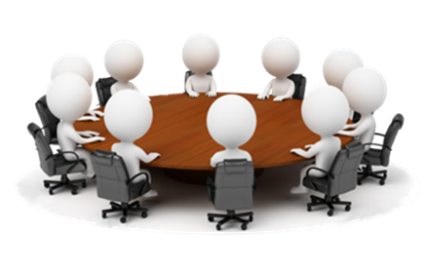

**V. Lesson 4. Factors of Office Accommodation**

1. Office Location
2. Office Building
3. Shape and Size of Office
4. Convenience to the staff and visitors
5. Safety of records and staff
6. Physical condition of office
7. Future expansion
8. The cost of office accommodation etc.
9. Type of building
10. Office lay out

Factors to be considered in selecting office location

1. Surroundings
2. Nearness to related business
3. Nearness to other units
4. Nearness to service units
5. Nearness to transport service
6. Availability of employees
7. Building constraints

Factors to be considered in selecting office building

1. Safety and security of the office and staff of the office
2. Provisions of lighting, ventilation, water system, free from dust, noise, smell, etc.
3. The budget of the office must match the cost of the office
4. Office building must be flexible to append additional floors for future expansion and requirement
5. The layout should meet the needs of machines, equipment, departments and human resources.

Shape and size of office building

The size of an office is based on the size of the business organization. If large scale business is carried on, the size of an office is also big and vice versa. The shape of office building affects the efficiency of employees.

Convenience to the staff and visitors

Adequate space should be provided for the convenience of office employees and the customers. Sales department which is mostly approached by the customers should be located in a place where easily accessed. There should be adequate space for canteens, washrooms, clock room, rest room, clinic, etc.

Safety of Records and Staff

The secured office building should ensure safety of records and staff also. In other words, the office building should have the special features like fire proof construction, fire escapes etc.

Physical conditions of office

Good working condition must be provided for smooth functions of office. Provisions for good water, adequate lighting and ventilation should be available. The office building should be free from dust, noise, fumes and obnoxious smells. The office buildings should have proper fittings of electricity, power, telephone, water connections and other fittings.

Future expansion

The office building should have a space for future expansion, if need arises. A provisions should be made for additional floor both in the owned building and in the rented or leased building.

Cost of office building

The main determinant of office building is based on its location, size and internal arrangements. The top management should give proper balance between the requirements of office and the capacity to pay for office space. The efficiency of the performance of office work cannot be sacrificed at the cost of economy in cost of the building.

Type of building

The secured office building cannot be partitioned for the requirements of an organization. There should be sufficient floor space for each worker and furniture required by him. Likewise, temporary partitions cannot be removed if required.

Office Layout

Office layout refers to the systematic arrangement of different facilities inside office area. It is the systematic and scientific management of machine, equipment, furniture and other resources in the office to achieve a business objective. It arranges different facilities in order to bring smoothness in work performance. It provides a smooth flow of work and motivates an employee to work hard and better.

Understanding Workplace Ergonomics

Ergonomics is simply defined as the study of the relationship of employees to their physical environment. More specifically, ergonomics is the science of designing the job to fit the worker, rather than physically forcing the workers’ body to fit the job.. it applies to the design of anything that involves people – workspace, sports and leisure, health and safety.

**VI. References and Supplementary Links**

Miranda and Gow, 2012 Office Management Principles And Practices

Medina, 2015 Office Basics Made Easy by: Learning Express Editors

Jessie F. Sergote, LPT, MBA, MRIBA (Sr.), DBA, 2016 Essentials of Administrative Office Management

<https://www.office-management.ph.com>

<https://www.modern-office.ph.com>

<https://www.office-accomodation.ph.com>

**Taguig City University**

Gen. Santos Avenue, Central Bicutan, Taguig City

**college of business management**

**bachelor of science in office administration**

**subject: ofa 2 – ADMINISTRATIVE oFFICE PROCEDURES AND MANAGEMENT**

**I. Title: Administrative Office Environment**

**II. Introduction**

According to Terry

“An individual’s performance is significantly conditioned by the environment in which he works. The cumulative effect of his total work environment is strong determinative of how well he marshals his abilities and skills, his attitude towards his work and his colleagues, and his enthusiasm for his work”.

**III. Overview**

Organizations are become more aware that office environment should become comfortable, safe an pleasant so it can produce offices with more contribution or productivity.

Office environment are becoming more fluid or less defined as a result organization become more flexible for new demands. This means the office environment should be designed to accommodate the needs of the office staff. Since the office is the central place of any organization and serves as internal and external clients, it is important to pay attention to the office environment. It also had an important effect on the efficiency, mental attitude and morale of the office workers.

**IV. Objectives:**

After studying this lesson, you are expected to be able to;

1. identify the good environment to establish an office
2. apply the right colors in the office by paying attention to color schemes, color combinations and the textures of materials used
3. choose the most appropriate type of lighting system

**V. Lesson 5.**  **Elements of Administrative Office Environment**

***Color Scheme***

Color must be considered first, in planning the physical factors of the office, because color has an effect of the lighting conditions.

Color coordinated offices aide morale, efficiency and productivity, and greatly help to reduce tension for most of those interviewed.

Psychologically affects

1. Efficiency: proper colors give the worker a feeling of pride in his surroundings and a desire to keep them neat and orderly.

2. Prestige: Attractive, cheerful and efficient appearing offices tent to inspire a feeling of confidence and trust; a drab uninviting, or poorly painted office can induce a feeling of doubt or mistrust.

3. Health: Color influences the mental attitude of the worker since it has a direct bearing on the quantity and quality of the work.

4. Morale: The removal of eye-strain and fatigue reduces nervous tension and other ill-effects that frequently influence the attitude of the workers toward their fellow employees and the firm.

Factors to Consider when Selecting Colors for the Office

* Location of the office
* Size of the office
* Shape of the office
* Operations performed in the office
* Impact of the color
* Floor cover, walls and furniture

***Lighting - Office Lighting***

Employees who do work that needs good lighting should position near the windows.

The ideal position for a workstation is one on which the lights falls from behind and slightly to the left of the employees. Where office windows face the sun, blinds should be provided so that the intensity of the light and glare can be reduced in sunny weather.

Lighting is perhaps the most important of the office physical conditions. Probably the best way to realize is that the importance of lighting to office management is to realize that virtually every office task is a seeking task. Since office work is mostly paper adequate lighting should be provided in any modern office.

Lighting must have the following characteristics:

* Sufficient quantity: sufficient quantity of light should be provided. The foot-candle is the unit measure of light and represents the amount of direct light obtained from a distance of one foot from the standard candle.
* Intensity: the light should provide the right degree of intensity and brightness. The light should be well diffused over the work place and should not cast any shadows. It should also be spread uniformly over all parts of the working surface.
* No glare: an efficient lighting system should not cause any surface glare. Direct glare on which results from sunlight or ceiling light can be prevented by the use of shadows or light fixtures.
* No contrast: abrupt contrast in lightning of work surface and remainder area should be provided.

**VI. References and Supplementary Links**

Miranda and Gow, 2012 Office Management Principles And Practices

Medina, 2015 Office Basics Made Easy by: Learning Express Editors

Jessie F. Sergote, LPT, MBA, MRIBA (Sr.), DBA, 2016 Essentials of Administrative Office Management

<https://www.office-management.ph.com>

**Taguig City University**

Gen. Santos Avenue, Central Bicutan, Taguig City

**college of business management**

**bachelor of science in office administration**

**subject: ofa 2 – ADMINISTRATIVE oFFICE PROCEDURES AND MANAGEMENT**

**I. Title: Administrative Office Environment**

**II. Introduction**

According to Terry

“An individual’s performance is significantly conditioned by the environment in which he works. The cumulative effect of his total work environment is strong determinative of how well he marshals his abilities and skills, his attitude towards his work and his colleagues, and his enthusiasm for his work”.

**III. Overview**

Organizations are become more aware that office environment should become comfortable, safe an pleasant so it can produce offices with more contribution or productivity.

Office environment are becoming more fluid or less defined as a result organization become more flexible for new demands. This means the office environment should be designed to accommodate the needs of the office staff. Since the office is the central place of any organization and serves as internal and external clients, it is important to pay attention to the office environment. It also had an important effect on the efficiency, mental attitude and morale of the office workers.

**IV. Objectives:**

After studying this lesson, you are expected to be able to;

1. Create an office environment with a sufficient amount of fresh air, as well as recommend the places where air conditioning can be used productively, and

2. Have an idea of peaceful working environment that will make employees feel comfortable to perform their job.

**V. Activity**

Name that picture…

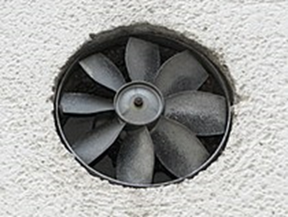 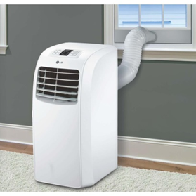

1.____________________ 2.___________________

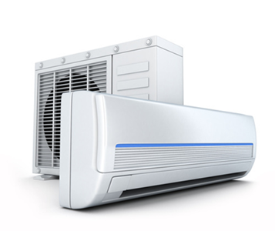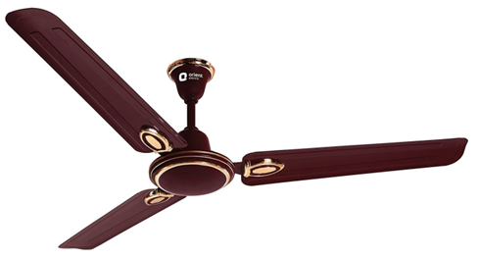

3._____________________ 4._____________________

**VI. Lesson 6.**  **Elements of Administrative Office Environment**

***Acoustics -*** Noise in the Office

One of the top causes of dissatisfaction and loss of productivity in the workplace is noise.

Unwanted noise can result in annoyance, heightened stress levels and reduced performance.

The maximum decibel of an office should be 90.

Ways to Control Office Noise

* Proper construction
* Controlling airborne and structural sounds
* Sound-absorbing materials
* Includes use of proper ceiling, floor, wall, and window-covering materials
* Sound absorbing devices
* Outing cover on equipment that cerates considerable noise.

***Condition of the Air – Proper Ventilation***

Ventilation in the office refers to the supply of clean and fresh air in right amount, at the right temperature and of the right humidity.

Fresh air must pass through office regularly. This is possible only when then office premises are properly ventilated. Absence of proper ventilation, air becomes stale, cause headache, fatigue and restlessness to the employees. Lack of proper ventilation makes a person sleepy and unduly tired and adversely affects his health.

Methods to maintain proper ventilation:

1. Natural ventilation: providing enough doors, windows and ventilators of the right type at the right places.
2. Artificial ventilators: use of electric fans, exhaust fans, air-coolers, air filters etc.

Types of Artificial Ventilators

* Electric fans
* Exhaust fans
* Air coolers
* Room heaters
* Air conditioning: air conditioning offers the following advantages

a. Maintains employee’s efficiency.

b. Safeguards employee’s health.

c. Keeps production cost low.

d. Protects the product or equipment in the plan.

**VII. References and Supplementary Links**

Miranda and Gow, 2012 Office Management Principles And Practices

Medina, 2015 Office Basics Made Easy by: Learning Express Editors

Jessie F. Sergote, LPT, MBA, MRIBA (Sr.), DBA, 2016 Essentials of Administrative Office Management

<https://www.office-management.ph.com>

<https://www.modern-office.ph.com>

<https://www.office-environment.ph.com>

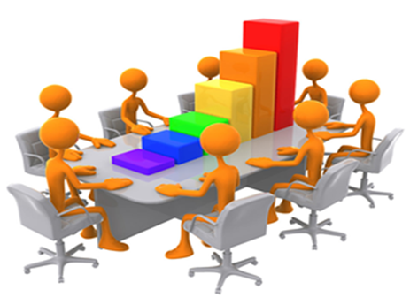

**Taguig City University**

Gen. Santos Avenue, Central Bicutan, Taguig City

**college of business management**

**bachelor of science in office administration**

**subject: ofa 2 – ADMINISTRATIVE oFFICE PROCEDURES AND MANAGEMENT**

**I. Title: Administrative Office Environment**

**II. Introduction**

According to Terry

“An individual’s performance is significantly conditioned by the environment in which he works. The cumulative effect of his total work environment is strong determinative of how well he marshals his abilities and skills, his attitude towards his work and his colleagues, and his enthusiasm for his work”.

**III. Overview**

Organizations are become more aware that office environment should become comfortable, safe an pleasant so it can produce offices with more contribution or productivity.

Office environment are becoming more fluid or less defined as a result organization become more flexible for new demands. This means the office environment should be designed to accommodate the needs of the office staff. Since the office is the central place of any organization and serves as internal and external clients, it is important to pay attention to the office environment. It also had an important effect on the efficiency, mental attitude and morale of the office workers.

**IV. Objectives:**

After studying this lesson, you are expected to be able to;

1. design and plan the office environment in such a way that safety and security requirements adhered to,

2. describe an office environment that will be appreciated by clients, and

3. choose office furniture that will be safe but useful to users.

**V. Lesson 7.**  **Elements of Administrative Office Environment**

***Interior Decoration***

Interior may be described as the art of a careful decoration in interior of a room or a building.

Interior decoration involves:

* A tasteful coloring of walls, doors, windows
* Placing of attractive art objects, pictures, paintings, and informative chats on the walls
* Floor covering, curtains and wall hangings, etc.

According to G. Mill: “The decoration of an office can have a noticeable effect upon the morale of the staff. Drab surroundings are depressing, pleasant surrounding as are conductive to good work”.

***Furniture***

After deciding the layout of the office accommodation and its decoration, it is necessary to turn to the furniture that is to be put in it.

Office furniture is the basic facility with which the employee identifies himself.

Modern and eloquently designed furniture not only improves the general efficiency of the employees, but adds to the prestige of the organization as well.

The number of pieces and the kind of furniture to be purchased for any depends on various factors:

* The number of departments and employees;
* The nature and volume of work to be performed; and
* The office space available for their suitable accommodation.

Guidelines or Factors to Consider in Selecting Office furniture

1. Cost: the important factor in purchasing office furniture is the cost. You should always keep the budget in mind while purchasing office furniture.
2. Suitability: the furniture is selected on the basis of nature of the job performed on them or the purpose for which they are required.
3. Design: the design of the furniture should be functional as well as artistic.
4. Durability: ordinary wooden furniture has longer life than steel furniture. “Sun-mica” surfaced furniture is also durable.
5. Saves space: Furniture should be selected in such a way that is doesn’t occupy much floor space.
6. Comfortable: the efficiency and morale of employees are increase by providing comfortable furniture.
7. Appearance: the physical appearance of the office furniture should be attractive and modern so that it adds to the look of the office.
8. Hygiene: it should be easy to clean the furniture and the floor under earth it.
9. Weight: the placement of office furniture may be changed on need basis.
10. Finish: glossy surfaces should be avoided because the create glares and tensions.
11. Fire risk: the wooden has more fire risk than metal furniture.
12. Saving Human Resources: some furniture has built in fire units which offer the opportunity to save movement and walking of the employees.
13. Safety: the furniture should be safe to use. There is no safety in using plate glass topped furniture.

***Security***

Need for safety in Office

First aid box should be kept in every office.

Precautions should be taken to ensure office security

1. Fire Precautions: adequate fire precautions should be taken to preserve the office records and documents.
2. Regulating Entry: entry of all visitors should be checked at the entrance.
3. Security Arrangements: Extensive security arrangements should be made in large organization.
4. Safeguarding Premises: office premises should be well guarded against security task.
5. A Fidelity Guarantee Insurance: individual or group insurance may be taken on the need basis.
6. Cash bond or Security: General, an employee may check the references given by the candidates while recruiting employees.
7. Reference Checking: the employer may check the reference given by the candidates while recruiting employees.
8. Identity Cards: All employees must be given cards or badges.
9. Safes: well-built and completely lock safes are a very good protection against fire and theft.

Security Equipment

The following modern security equipment as available for the office as security device shall be installed:

1. CCTV Cameras
2. Fire Alarm System
3. Spy Pen Camera
4. Intrusion System
5. Visitor Management System
6. Guard Monitoring System
7. Customized System
8. Security Surveillance system
9. Biometric Access Control System
10. Mobile Based Security System
11. Biometric Time Management System

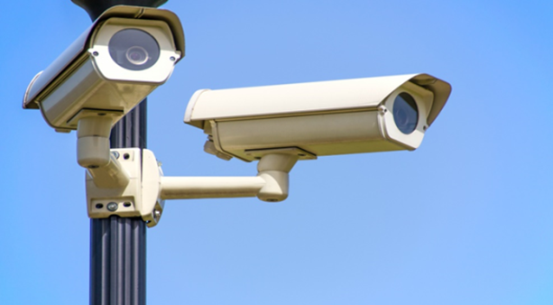

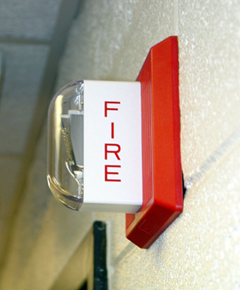

**VI. References and Supplementary Links**

Miranda and Gow, 2012 Office Management Principles And Practices

Medina, 2015 Office Basics Made Easy by: Learning Express Editors

Jessie F. Sergote, LPT, MBA, MRIBA (Sr.), DBA, 2016 Essentials of Administrative Office Management

<https://www.office-management.ph.com>

<https://www.modern-office.ph.com>

<https://www.office-environment.ph.com>

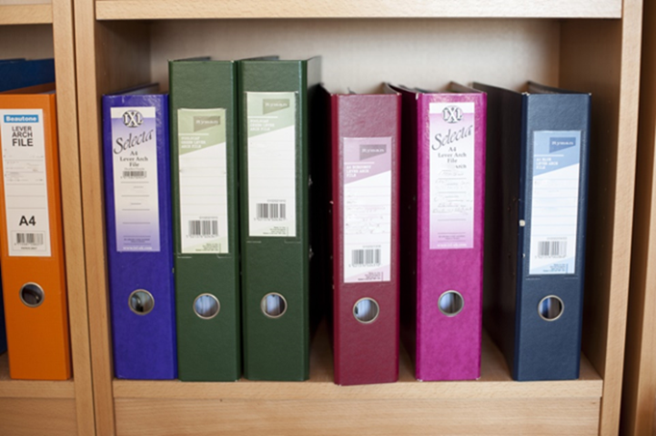

 **Taguig City University**

Gen. Santos Avenue, Central Bicutan, Taguig City

**college of business management**

**bachelor of science in office administration**

**subject: ofa 2 – ADMINISTRATIVE oFFICE PROCEDURES AND MANAGEMENT**

**I. Title: Modern Office Machines and Equipment**

**II. Introduction**

Equipment and machines have become an essential part of modern office. A large number of appliances and machines are used for speedy, accurate and efficient performance of office activities. With fast technological development, there is mechanization in office operations resulting in increase of efficiency.

**III. Overview**

There are various machines and appliances which increases speed and accuracy of the operations, and reduce work tensions etc.

Office machines also effect saving in the cost of office operations by increasing the output of the work.

**IV. Objectives:**

After reading this module, you are expected to be able to

1. recall the importance of using office equipment and machines,
2. explain the objectives of office mechanization and describe its advantages and disadvantages and lastly to
3. identify the various types of office equipment and machines.

**V. Lesson 8. Mechanization**

Objectives of Mechanization

Mechanization in the office refers to the process by which machines and equipment are introduced with a view to speeding up the administrative process. The decision to shift from manual to machine operations is governed by a comparison of the cost incurred with the cost saved. All the expenses and costs should be weighed against the savings made by their use. The introduction of mechanism leads to saving in time and reduced clerical costs, in the accuracy and speed of operations and in safeguard against fraud.

Disadvantages of Mechanization in Office

1. Heavy investment
2. Waste – idle machine is a waste.
3. Retrenchment problem
4. No trained staff
5. Increase cost of operation
6. No power – no work
7. Break down of machine
8. Set right the machines
9. Affect urgent work
10. Reduces profit
11. Obsolescence
12. Slaves of machines
13. Noise and space problems
14. Dislocation of work.

Factors in Selecting Office Machines

1. Ease of operation
2. Flexibility
3. Durability
4. Portability
5. Adaptability
6. Service
7. Operating cost
8. Reputation of the supplier
9. Styling
10. Cost

Types of Office Machines

1. Type writer – the most commonly used and best known of office machine.
2. Stenographic machines – this machine is also referred as shorthand or steno typing machine.
3. Dictating machines – dictation to a stenographer writing in shorthand or typing on a stenographic machine the presence of both dictator and stenographer is needed.
4. Duplicators – it frequently happen that more than one copy of a letter or a document is required. The simplest method is to make the copies at the same time as the original using carbons.
5. Photocopying machines – the essence of the photocopying of any document is that it is an exact photographic copy of the original which obtained by the use of a special machine, not requiring the assistance of a typist.
6. Accounting and tabulating machines
7. Addressing And mailing machines
8. Punched cards machines
9. Electric computers – are the latest additions to the long list of office machines. A computer is a replica of a human brain and performs all types of clerical operations quickly and accurately, it is used to solve the business problems through the application of a variety of logical, mathematical and decision making techniques.

**VI. References and Supplementary Links**

Miranda and Gow, 2012 Office Management Principles And Practices

Medina, 2015 Office Basics Made Easy by: Learning Express Editors

Jessie F. Sergote, LPT, MBA, MRIBA (Sr.), DBA, 2016 Essentials of Administrative Office Management

<https://www.office-management.ph.com>

<https://www.modern-office.ph.com>

<https://www.office-mechanization.ph.com>

<https://www.office-machines-and-equipment.com>

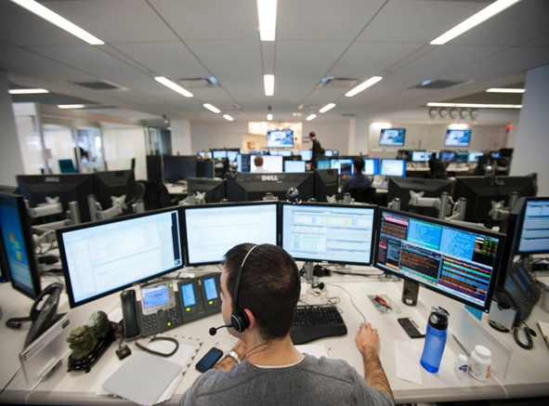

**Taguig City University**

Gen. Santos Avenue, Central Bicutan, Taguig City

**college of business management**

**bachelor of science in office administration**

**subject: ofa 2 – ADMINISTRATIVE oFFICE PROCEDURES AND MANAGEMENT**

**I. Title: Records Management**

**II. Introduction**

The volume of paper work handled in a modern office today is enormous. Hence record management has also become highly important. The record is a written matter which is prescribed for future reference and management is related to the way or the technique which are used to manage the different types of records. Therefore, record management is the management and the control of records. Letters, invoices, cheques, vouchers, price lists, personnel records, tax records, costing records are the examples of records.

**III. Overview**

“Record Management is, knowing what you have, where you have, where you have it, and how long you have it.”

**IV. Objectives:**

After studying this module, you are expected to be able to

1. explain the importance and functions of records management,
2. identify the elements, functions and objectives of filing,
3. explain the advantages and essential of a good filing system,
4. enumerate different bases of classification of files and
5. outline the filing procedure.

**V. Lesson 9. Importance of Records Management**

1. Helpful to make progress report.
2. Used as an evidence.
3. Basis for decision making
4. Help in planning.
5. To detect errors and wastages.

Types of Records

1. Correspondence record
2. Personnel record
3. Accounting record
4. Legal record
5. Miscellaneous records

Importance of record Retention

1. It preserves active records for future reference
2. It helps in taking prompt decision
3. It provides written legal evidence in the court
4. It enhances the efficiency of the office as essential records are readily available.

Stages in Records Management

1. Creation of Records
2. Utilization of Records
3. Storage of Records
4. Retrieval of Records
5. Disposal of Records

Concept of Filing - a filing is a process of arranging and preserving original records or their copies in such a way that whenever needed, they could be located immediately. It preserves the letters and documents for future so that it can be used whenever required.

Importance of Filing

1. Preservation of records
2. Facility for ready reference
3. Rapidity in preforming office work
4. To facilitate in planning and policy making
5. Providing evidence
6. Maintaining goodwill and building image
7. Following up

Qualities of Good Filing

1. Compactness
2. Accessibility
3. Economical
4. Simplicity
5. Safety
6. Flexibility
7. Cross-reference
8. Classification

Classification of Filing

1. Alphanumeric filing
2. Numerical filing
3. Geographical classification of filing
4. Subject filing

Concept of Indexing

Indexing can be defined as the alphabetically arranged list of items given at the end of the printed text with the page number on which the items can be found. It is used to provide information about chapter or topic, books word and meaning in the dictionary. Indexing help in quick identification of files and document in the filing system of office. It not only help in the quick location of the document but also help in systematic arrangement of a document in a file.

Purpose of Indexing

1. To ensure easy and prompt location of file and document
2. To support in developing systematic filing system in an office
3. To maintain secrecy about internal matter of business
4. To bring smoothness in an office performance
5. To improve efficiency of employees
6. To reduce operational expenses of office

**VI. References and Supplementary Links**

Miranda and Gow, 2012 Office Management Principles And Practices

Medina, 2015 Office Basics Made Easy by: Learning Express Editors

Jessie F. Sergote, LPT, MBA, MRIBA (Sr.), DBA, 2016 Essentials of Administrative Office Management

<https://www.office-management.ph.com>

<https://www.modern-office.ph.com>

<https://www.office-mechanization.ph.com>

https://www.record management.com

